Portfolio Model and Risk Management

**Portfolio Optimisation: The Manual**

**Revisions**

|  |  |  |  |  |
| --- | --- | --- | --- | --- |
| Rev. | Date | Author | Description | Approved by |
| v.1.0 | 23/07/12 | Telis Dosis | Originally taken from Christos manual and refreshed according to BLU document standards |  |
|  |  |  |  |  |

1 Introduction 4

2 Portfolio Optimisation Notes 4

# Introduction

This document outlines the design and architecture of the Portfolio Optimisation System. The optimisation methodology permits the portfolio allocation to be evaluated with inputs as to

* concentration limits
* maximum daily portfolio
* volatility
* maximum absolute drawdown

The inputs being provided by the User. With these inputs and by using different statistical approaches, model portfolios can be generated. These inputs take account of the qualitative assessments of the user. Every trade is assessed and monitored for its return volatility, maximum drawdown and probability of drawdown and is sized based on a maximum portfolio drawdown limit over a pre-defined time horizon.

The system is developed under Matlab © and is also utilizing publicly known Statistical and numerical methods. The application has an Excel Interface module to facilitate the use and manipulation of input and output data.

# Portfolio Optimisation Notes

## Inputs

The main source file needed for the portfolio optimisation is the “PORTFOLIO.xls” excel file (typically found in “X:\data\PNL\”). In particular, the “TRADE INFO” worksheet contains essential information about the characteristics of each folder such as the expected Profit, expected Time, Risk Capital and Probability of Loss. The user may enter his input in the green part of the worksheet which is automatically transformed to the program needed input in the red section. The “GENERAL INFO” worksheet contains general input information such as Target Volatility, Max Daily STD, Max Portfolio Loss, AUM.

The program considers both historical correlations calculated by past historical data stored in the “DAILY P&L” worksheet of the “PORTFOLIO.xls” and GlobeOp correlations downloaded from their FTP server on a daily basis.

## Correlation and Calculations

The historical correlations are calculated pairwise only for those pairs of trades that have at least a common history of 20 business days. Otherwise the correlation coefficient is assumed to be 0. Note that the correlation matrix estimated using the above mentioned procedure is not necessarily a strict correlation matrix (i.e positive semi-definite). Thus it has to be transformed to a valid correlation matrix by employing a singular value decomposition (SVD).

Portfolio optimisation also uses an additional correlation matrix (max loss related) which is linked to so called joined default events (i.e multiple trades hitting their risk capital simultaneously).

Apart from the historical and Globeop’s correlations, the program runs a series of scenarios with the maximum loss constraint activated/deactivated for various correlation configurations. For example, the non-diagonal elements of the correlation matrix are equal to 0.2, 0.35 or 0.5 indicating weak, medium or strong correlation respectively. Similarly the max loss correlation matrix can be deactivated (i.e all non-diagonal elements equal to zero) or various configurations (0.2, 0.35 or 0.5 as with the usual correlation matrix). All these combinations are essentially predefined but can be easily modified upon request.

## Execution and Results

The program is scheduled to run on a daily basis at 14.30. Execution takes 2-3 hours. The results are stored in “X:\data\portfolio optimisation\portfolio optimisation.xls’. Each day is stored as a separate worksheet named after the date in the format “yyyymmdd”. First, we tabulate the trades with their historical, user estimated, and Globeop standard deviation (6M daily, 2Y daily, 6M 2 weeks, 2Y 2 weeks). Then we provide a list of extreme positive and negative correlations based again on historical and Globeop data. The marginal correlation of each trade with the entire portfolio is produced. Next to it, we provide the results of the portfolio optimisation using different combinations of correlation matrix and max loss correlations. We follow a particular notation to indicate the combination. The first row will indicate “Hist” or “Globeop” for historical or Globeop correlations respectively, or 0 or 0.35 or 0.50. The second row refers to the max loss correlation. When this particular number is 0, then the max loss constraint is inactive. Next to this pair of numbers, we have a set of 6 numbers. The first couple is the PV before and after optimisation, the second pair is the VaR before and after optimisation, and the third one is the Max Loss constraint before and after. Finally the next three columns indicate the trade and the allocation (in units and percentage respectively). This pattern is repeated for all combinations.

## Screenshots from Results

### Trade Info

The following screenshot shows the trade info from the PORTFOLIO.xls file. This sheet contains the entire portfolio, including both live and closed folders. For each folder, the relevant characteristics (such as the risk capital, expected profit, time horizon, and the probability of default) are provided. These parameters are used as inputs in the portfolio optimisation’s cost function. The user fills the information on the white and the red area of the sheet above. The green area is derived from the numerical info in the red cells.

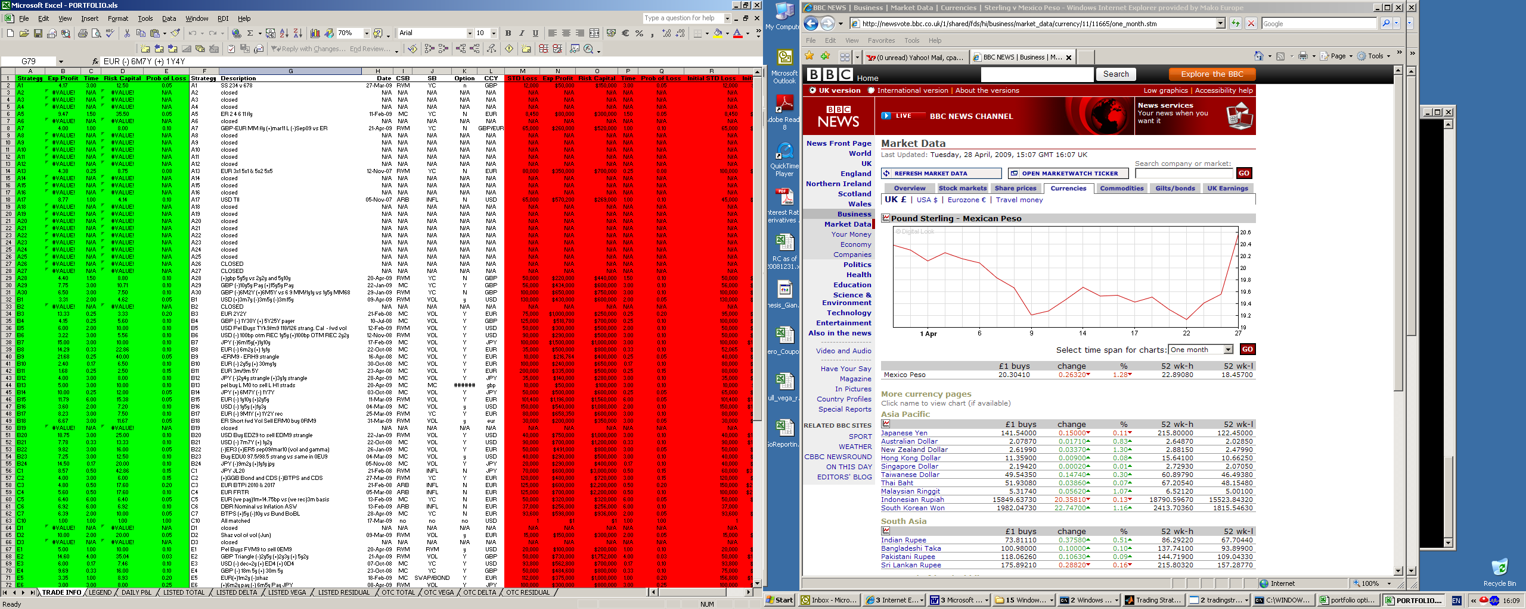

Figure 1: TRADE INFO (PORTFOLIO.xls)

### General Info

The following table shows the General Info from the PORTFOLIO.xls file. This sheet provides general information about the entire portfolio such as the portfolio’s target volatility and assets under management (AUM). The AUM cell should be updated whenever there is a significant change in the fund’s assets. The rest of the cells are meant to be static information which will change infrequently.

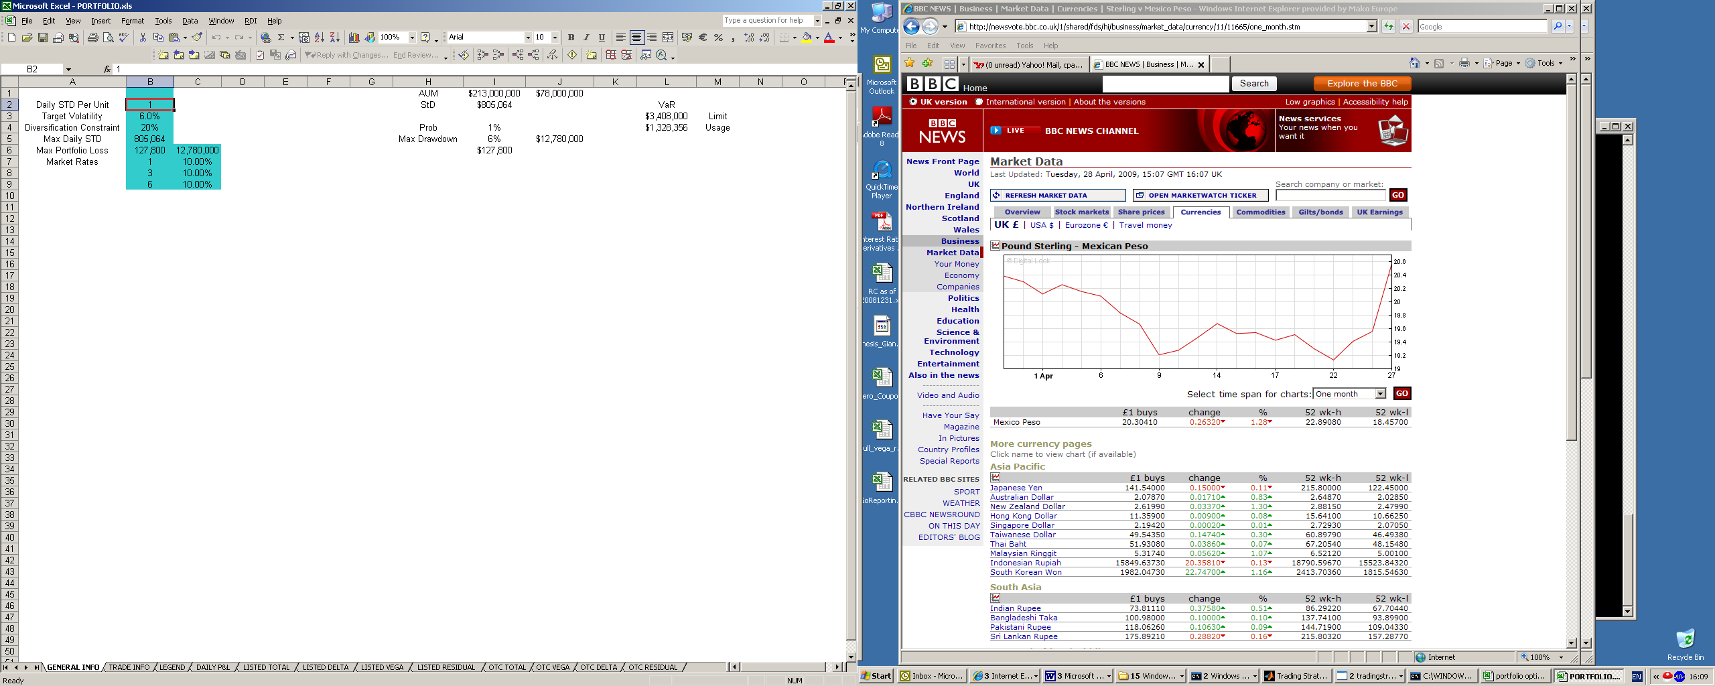

Figure 2: GENERAL INFO (PORTFOLIO.xls)

### STDs

The following screenshot shows the STD’s in the portfolio optimisation file. This sheet provides the daily standard deviation for each folder, provided by the user as an initial estimate, calculated by historical daily P&L data, as well as computed by GlobeOp using their proprietary factor analysis algorithms.

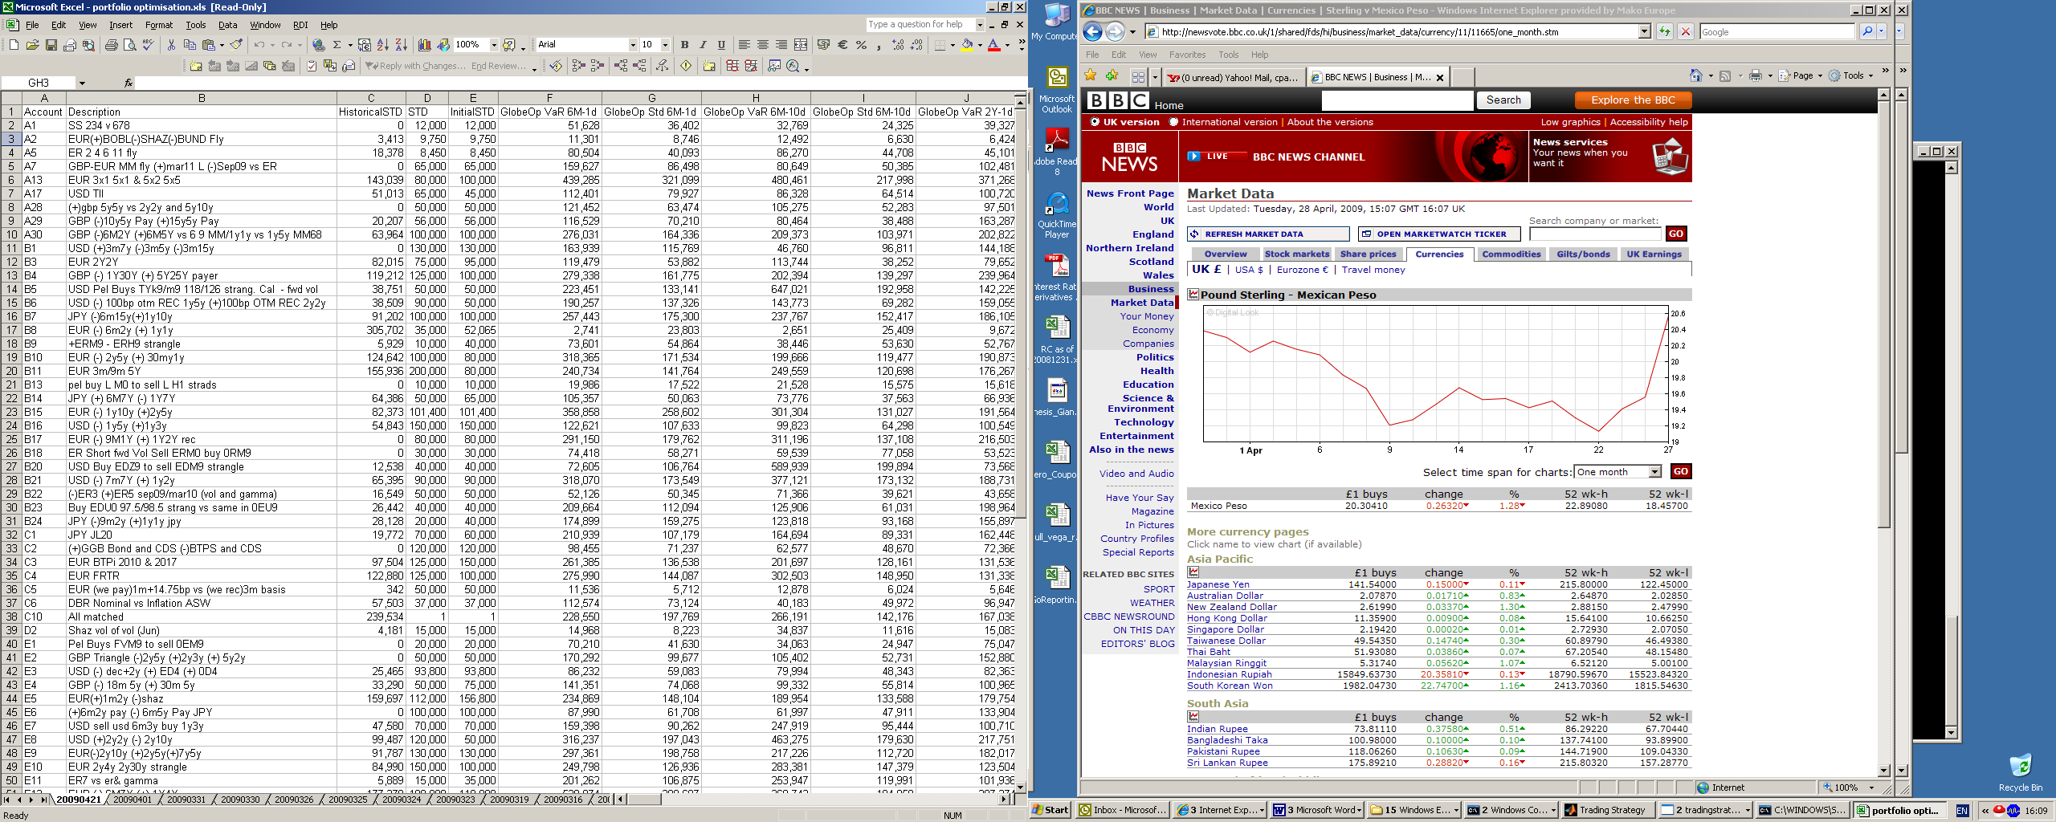

Figure 3: Portfolio Optimisation: STDs

### Correlations

The following figure shows the correlations from the portfolio optimisation. This sheet presents the most correlated pairs of folders either negative or positive, based either on historical daily P&L data or calculated by GlobeOp using their proprietary factor analysis methodology. The results are used by the portfolio managers to estimate the risk of the portfolio.

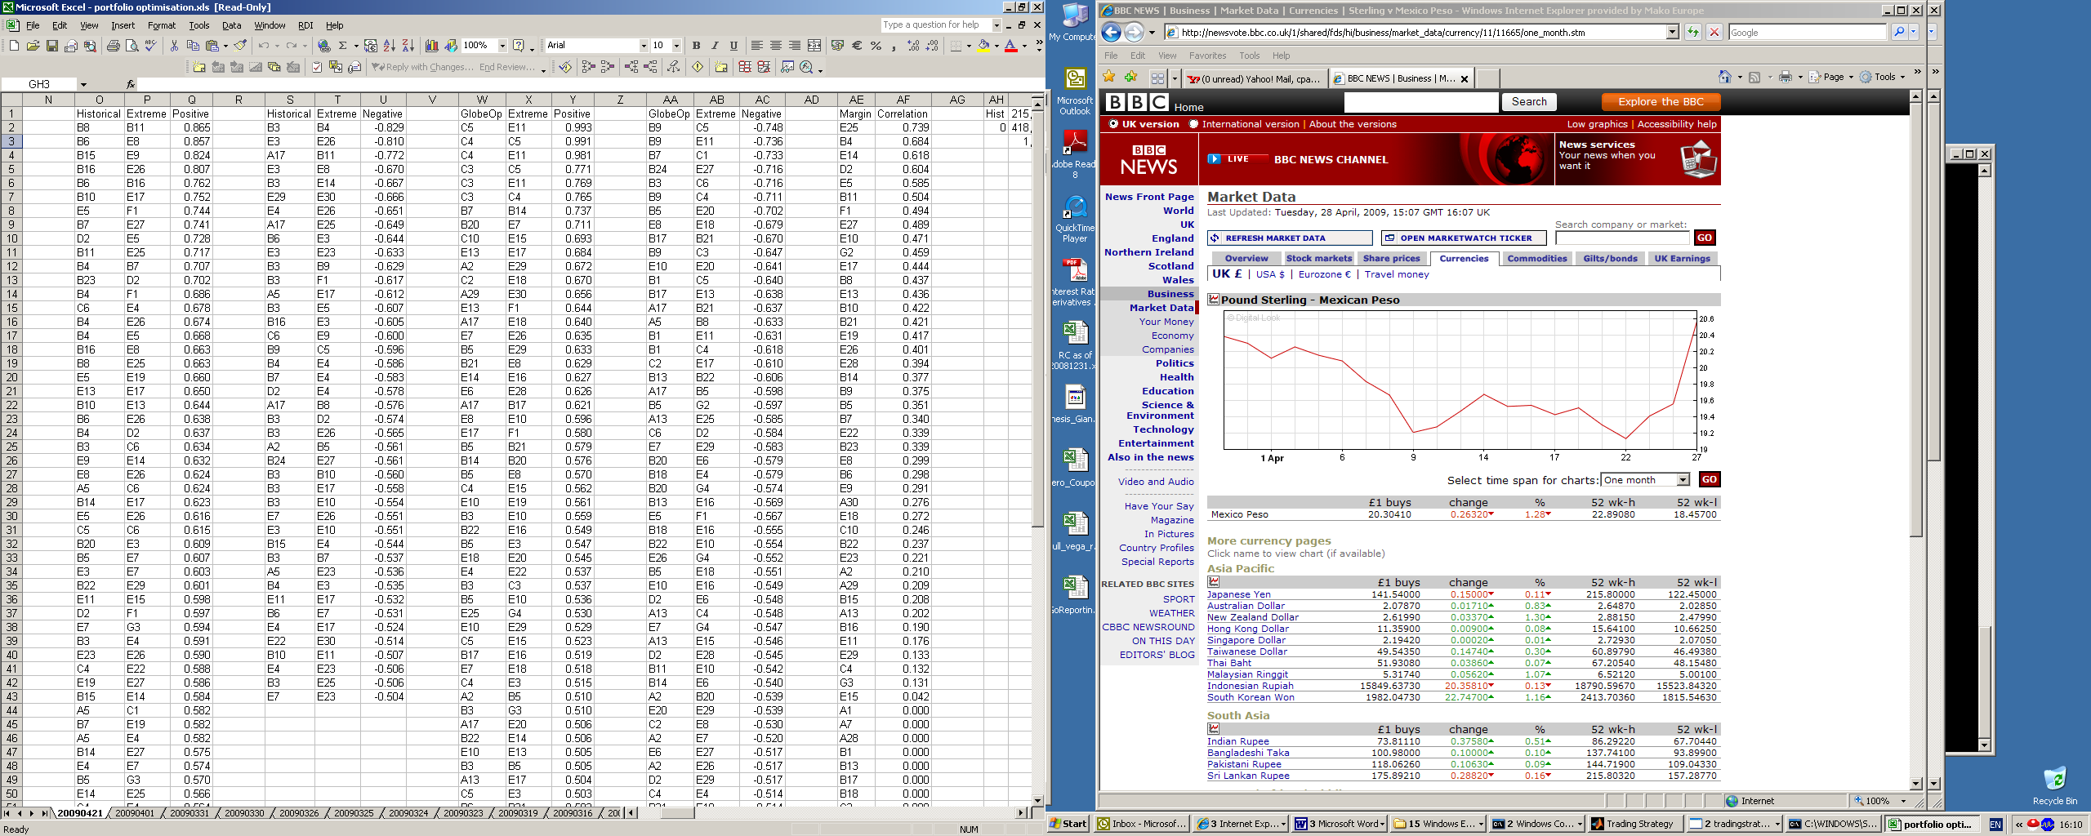

Figure 4: Portfolio Optimisation: Correlations

### Allocations

The following screenshot shows the allocations within the portfolio optimisation file. This sheet tabulates the results of the portfolio optimisation. In particular, for each scenario (i.e. set of correlation matrices, including the maximum drawdown correlation matrix) we produce the optimal portfolio allocation in terms of units allocated (as well as in overall percentage allocation). The results are used as a sensitivity analysis to compare different optimal allocations under different scenarios. Hence, we can estimate whether the portfolio in over/underinvested.

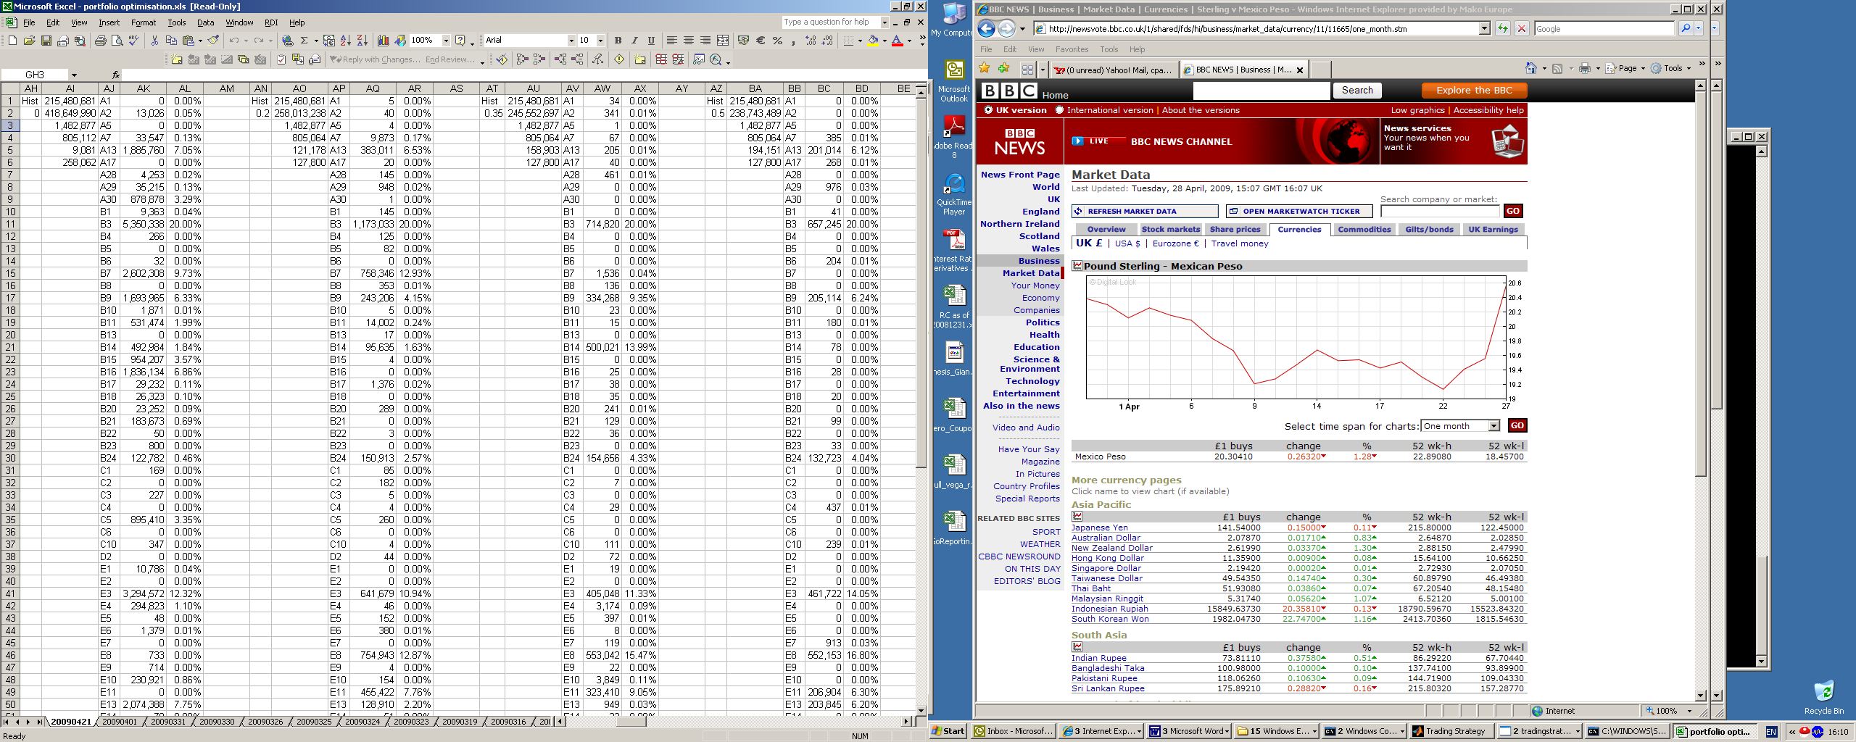

Figure 5: Portfolio Optimisation: Allocations